The Jam Board

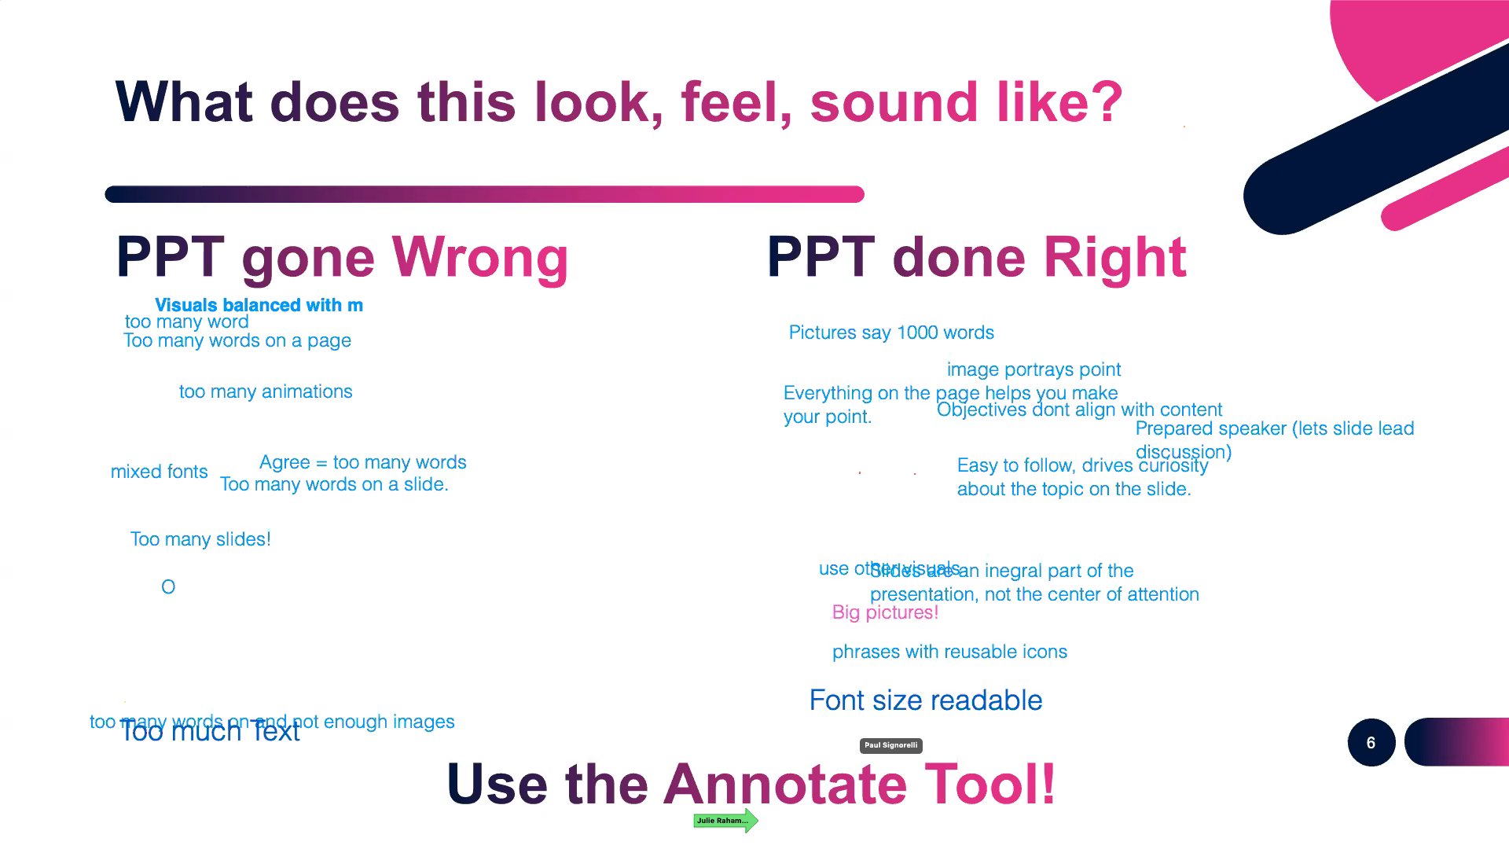
Good vs Bad PowerPoint: What did everyone say?

Insights from the group:

How many times do people have to hear/see a message before they actually register it?

- From Anna Adams to Everyone : at least 5
- From Laura Fothergill to Everyone : also differences between hearing/reading, in-person/virtual communication for different messages
- From Paul Signorelli to Everyone : People need to hear something at least five times before they get it. People need to hear something at least five times before they get it. People need to hear something at least five times before they get it. People need to hear something at least five times before they get it. People need to hear something at least five times before they get it.

Views about blended learning programs.

- From Anna Adams to Everyone : Yes... break them up into smaller chunks, but you have to make them close together.
- From Michele Knight to Everyone : You ca take concepts very deep
- From Paul Signorelli to Everyone : I'm designing a train-the-trainer series right now that, in its online version, goes in two-hour segments twice a week rather than the original blended version of a full day onsite followed by a few shorter online sessions.
- From Anna Adams to Everyone : More virtual sessions, for sure.
- From Laura Fothergill to Everyone : What tangible tool has been helpful to you? Share in your group.
- From Anelle to Everyone : Use a microphone (This was repeated by others)

Important Considerations Before Design

- From Sherri to Everyone : engagement
- From Anelle to Everyone : engagement
- From Eivina Muniute-Cobb to Everyone : clarity
- From Michele Knight to Everyone : Engagement for sure
- From Anna Adams to Everyone : Engagement!
- From Vito Scotello to Everyone : able to be understood
- From Sherri to Everyone : edutainment
- From Willpower Harris to Everyone : compliment speaker
- From cassandra.mcmillan to Everyone : Bite size - easy to read
- From Anne Solomons, Touch Point Training Consultants to Everyone : fun
- From Vito Scotello to Everyone : big enough to read
- From Vito Scotello to Everyone : animae with a purpose

Design Tips

- From Paul Signorelli to Everyone : Love what Jessica just said about putting images on a series of slides and then working with them. I often do that to create a narrative flow before I start writing my "script" in the notes field of a slide. (Learned that from Cliff Atkinson's "Beyond Bullet Points.")
- From Paul Signorelli to Everyone : Expanding on Jessica's post-it note trick: a wonderful instructional designer I know puts sticky notes on a door in his workspace and then rearranges them as he develops what wants to produce.
- From Paul Signorelli to Everyone : As always, some of the best moments in these ATD SFL sessions come from watching great presenters in action. Love how Jessica is using what is in essence a "flexible PowerPoint deck"--one where she clearly has no intention of using every slide, and moves to specific slides based on audience preferences. Also love how transparent she is about dealing with the tech glitches; keeps us with her rather than being distracted by the mishaps. #TruePro
- From Vito Scotello to Everyone : I use powerpoint as my sticky notes. Using a sirt view, I jot notes on each slide and move them around.
- Anna Adams to Everyone : Slide Sorter view is awesome for arranging slides.
- Lara Loucks to Everyone : i do the same as Vito
- From cassandra.mcmillan to Everyone : Great Job Jess!

